Link to website: <https://isabellaaguilera76.wixsite.com/my-site-3>

The Facebook post I created to show she now has a website using Canva:

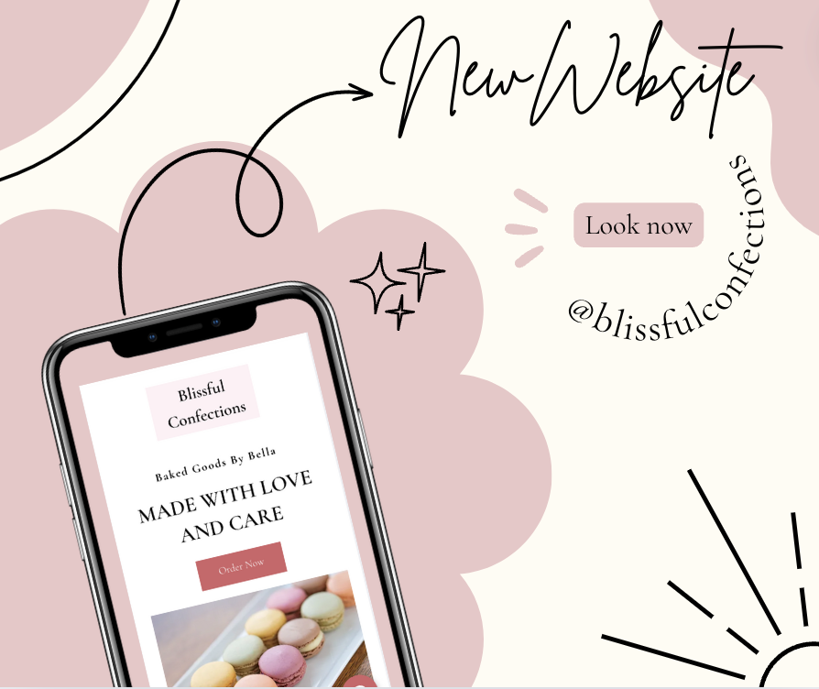

Caption for new website post:

Exciting news! I just launched a brand-new website made by Jayda Friedenfels, she is currently pursuing Digital Marketing at UWO and graduating in December this year! Reach out to her if you want her to create/edit a website for you! 🎉

Visit my site to explore some of the menu items, place orders, and get an idea of my prices. Thank you for your continued support—your next delicious indulgence is just a click away! 🧁💻📱

✨New Halloween menu coming soon!✨

#NewWebsite #BlissfulBaking #SweetTreats

A future Halloween Facebook post I created using Canva:

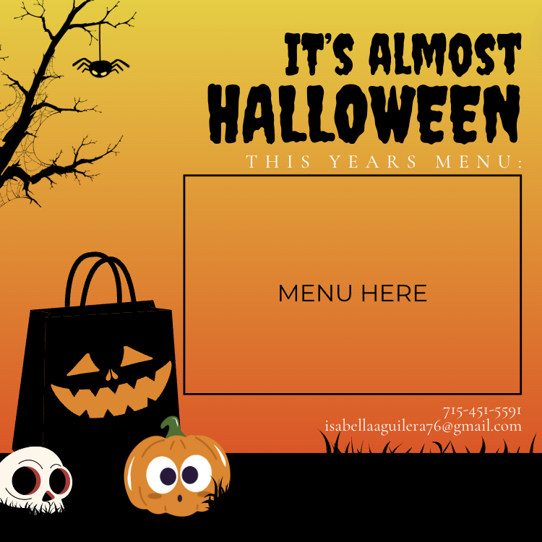

Possible logos I created using Canva:

