Content Calendar Examples:

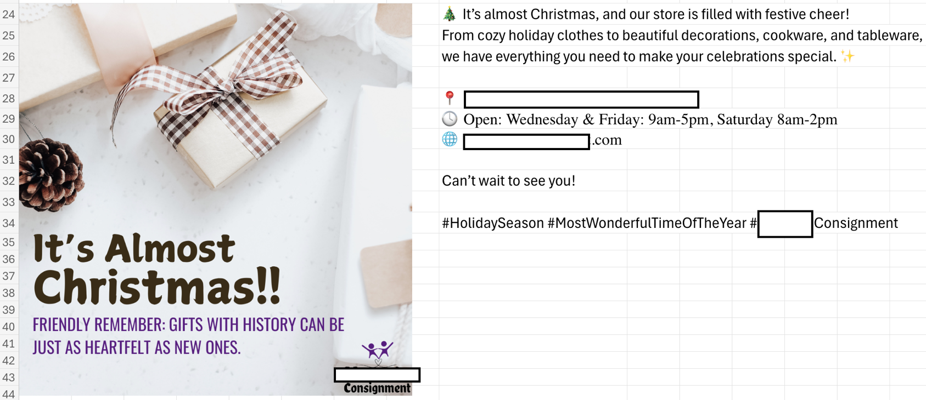

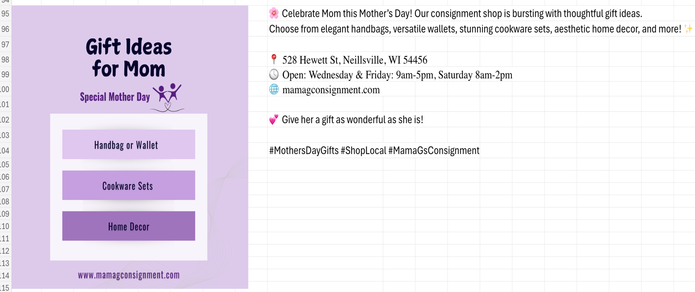

Sitemap:

Suggestions Included:

* Move Shop All page as one of the first pages rather than at the end to get it out of the “more” area.
* Add a vintage apparel landing page due to it being a highly searched keyword.
* Add the VIP Membership page to the About Us page to condense because the About Us page included only a tiny section.

